TRADER TRAIL Issue 1
Introduction
This leaflet describes the Wokingham Trader Trail. Members of the public are encouraged to walk the trail and visit the traders.
The leaflet is available from the Wokingham Town Council Information Centre and Wokingham Library.
Unless otherwise stated the photographs are courtesy of “Wokingham A Pictorial History” by J. and R. Lea.
The objectives are to: -
• Promote the history of Wokingham
• Get people of all ages walking
• Support our independent traders.
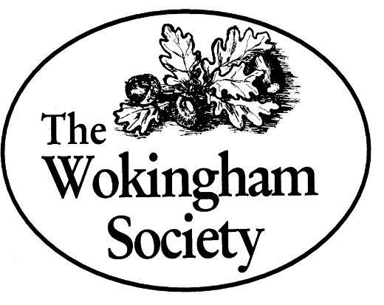
Note – from time-to-time premises change hands and this will be reflected in any future reprint of the leaflet.

The Wokingham Society
This leaflet has been provided by the Wokingham Society
The main purposes of the Society are as follows. The Trader Trail supports purpose 2: -
1 Encouraging the conservation of the character and traditions of Wokingham as an historic market town 2 Promoting study of the history of Wokingham and interest in our heritage 3 Welcoming new development and business which enhance and invigorate the town while constructively opposing measures that do not 4 Proposing improvements to the town's environment and amenities.
Directions
Start the trail at Shute End, then walk along Broad Street, turn left into Rose Street, return via Peach Place enter Peach Street and turn left to visit the traders. Return down Peach Street and enter the Market Place, walk towards Boots, cross the road to Piccolo Arco and then walk down the Market Place to the right of the Town Hall. Continue into Denmark Street, visit Giggling Squid via the Plaza, then return to Denmark Street, cross the road, and walk back towards the Town Hall.

- 2 Shute End: Bosphorus Barber Shop, was once W.H. Howard, Ironmonger.
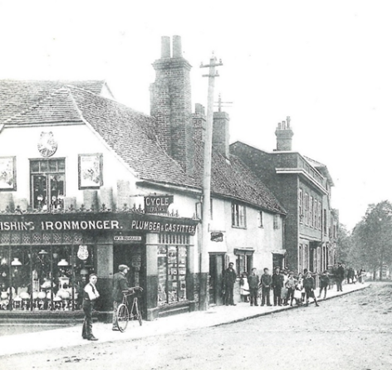
On the left at the start of Shute End there was once Mr. W. H. Howard’s ironmongery. The associated photograph was taken about 1900. It was later Mrs M. Smith’s, confectioner.

- Montague House, 31 Broad Street: Chalk Restaurant, was once Grosvenor House School.
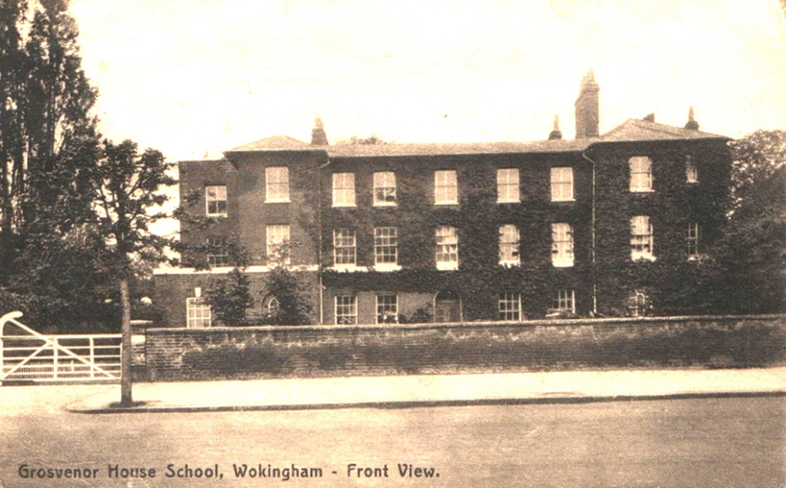Postcard from c. 1920
The original building on this site was thought to have been built in the 16th Century, becoming an educational establishment in the early 17th Century.
Montague House almost certainly takes its name from two Henry Mountagues, father and son, the latter a prominent wealthy schoolmaster, who inherited the premises from his father. The current building dates from the early 18th Century, when it was built for and occupied by Lt. Col. Adam Williamson, Deputy-Lieutenant of the Tower of London.
In the 1790s it became a boarding school for young ladies but returned to residential use in 1802.
By 1920 the premises had become a school once more (Grosvenor House School, transferred from Tudor House), until the 1930s when it moved elsewhere. A Wellington School master was resident there until 1948, but it was sold in 1951 to Berkshire County Council. It again reverted to an educational establishment until the Library transferred there from the Town Hall in 1970, before again becoming a higher educational establishment as part of Bracknell and Wokingham College in the 1990s. A new library was built in Denmark Street.
Montague House was subsequently sold to a commercial company in 2004 and is currently a restaurant on the ground floor with managed apartments on the first floor.

- 15 Broad Street: Flower Corner Florist, was once Pither & Son Butcher and then the Paris House.
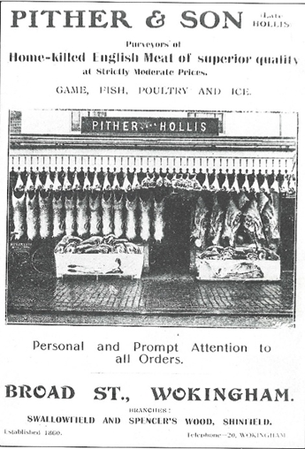
The Pither family were butchers in Wokingham from 1860. Note their signage can still be seen on the outside of the building. In the 1920s and 1930s 15 Broad Street was the Paris House, a tailor’s that also provided dry cleaning and repairs.

- 10 Broad Street: Nationwide, was once the Electric Theatre.
Opened on 10th March 1913 as Wokingham’s first public cinema by the Mayor, Councillor W. T. Martin, it experienced the change in films from silent to sound and black and white to colour.
Affectionately known as “the flea pit”, it was popular with youngsters in the town.
Admission to the front rows was three pence, middle rows, sixpence and back rows one shilling and threepence.
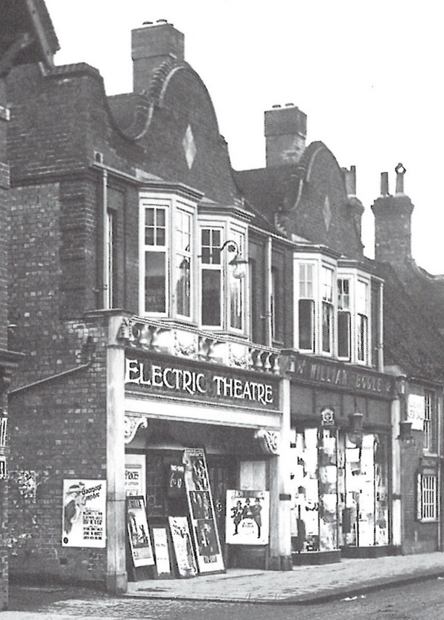
Photograph courtesy of the Wokingham Society’s Blue Plaque Trail

Wokingham Picture Palace Ltd. went into liquidation in September 1932 and was then owned by D.W. & R.T. Hayward.

- 7 Broad Street: Winkworth Estate Agents, was once James Watts, Estate Agent.
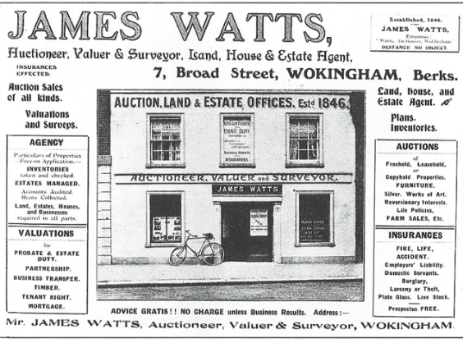
A 17th century house has been used as an estate agents’ office for nearly 150 years. In the late 19th century it was run by James Watts.

- 16-18 Rose Street: Wade Charity Shop, was once F. Knight, Plumber.
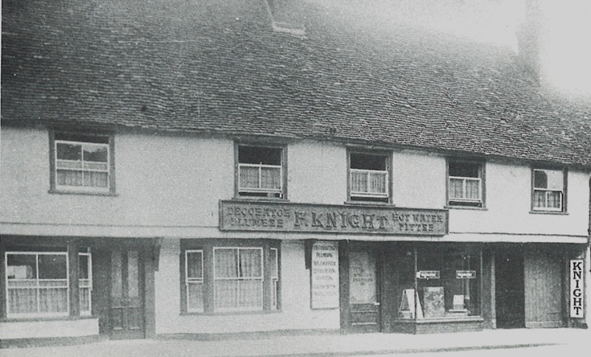
The associated photograph was taken in 1925 when 16-18 Rose Street was the business premises of F. Knight, a plumber. The building was originally a 15th century house which had an upper floor inserted in the 16th century.
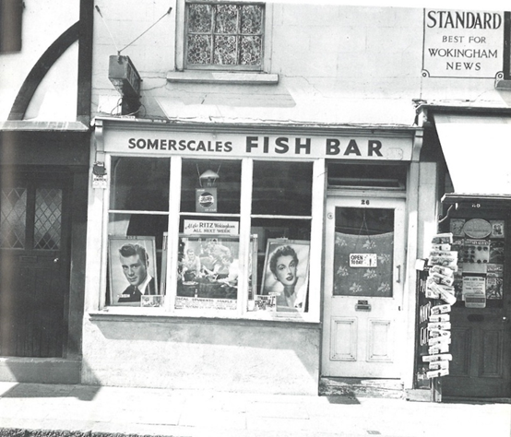
- 26 Peach Street: Haka Chinese Take Away, was once Somerscales Fish Bar.

Situated next to the Redan public house, Somerscales supplied fish and chips both before and after the Second World War.

- 19 Peach Street: Holland & Barrett, was Evans, Leather Shop.
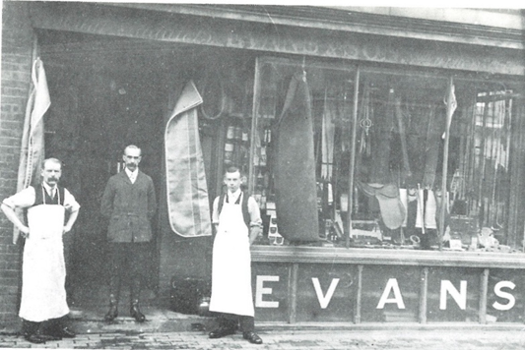
Mr. Evans’s leather shop was at No. 19 Peach Street from 1863 to 1918. The associated photograph taken in 1905 shows Mr. Evans with Mr. Lovelock on the left and Charlie Rideout on the right, who was killed in the First World War.
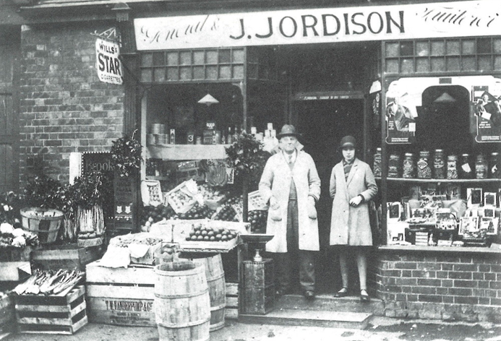
9. 7 Easthampstead Road: Vacant now, was once Jordison, greengrocer.
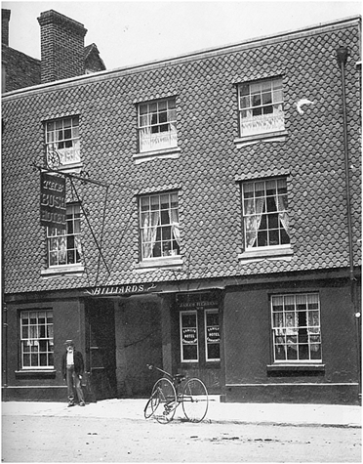
10. 37 Market Place: Grape Tree, was once The Bush Hotel.
The timber-framed 15th and 16th century buildings that make up much of the present-day Bush Walk were previously part of the Bush Inn. After being a stagecoach for 100 years, by 1901 it had become a hotel.
It was closed in 1986.
Photograph, courtesy of closed pubs.co.uk, was taken in 1901.
11. 38 Market Place: Peach Dental Care, used to be the original Boots.
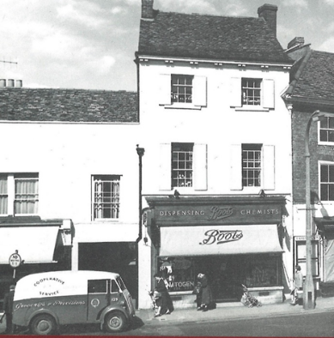
Boots the chemist was originally based in smaller premises in the Market Place. The associated picture was taken in the 1950s.

12. 40 Market Place: Boots, was once John Eighteen, Fishmonger and then Heelas Department Store.
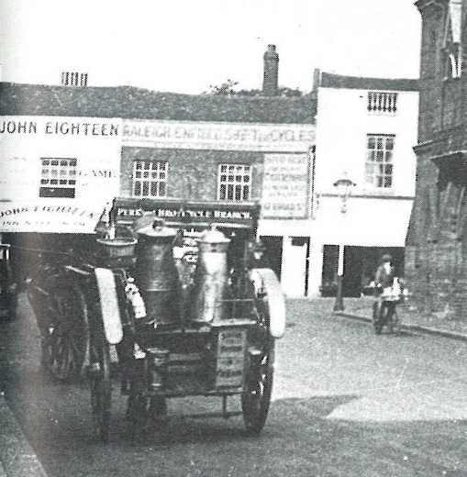
John Eighteen was the fishmonger at No. 40 Market Place for many years. The associated photograph was taken in the mid-1920s.
Heelas the department store occupied most of the north side of the Market Place One building remains now (2025) as part of Boots; the rest was demolished and redeveloped in the late 1960s.
13. 41 Market Place: Boots Optician, was once T. Maris, Saddler, and Harness Maker.
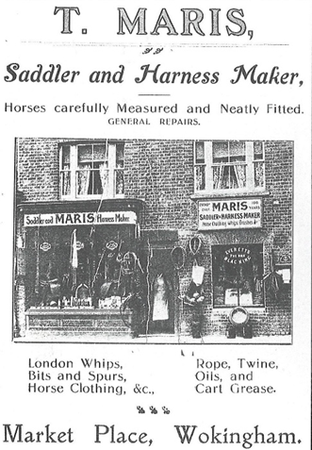
The leather industry in Wokingham resulted in Wokingham having a number of harness makers in the town, including T. Maris, towards the end of the 19th century.

14. Town Hall Unit 1: Piccolo Arco Restaurant, used to house Wokingham’s fire engines.
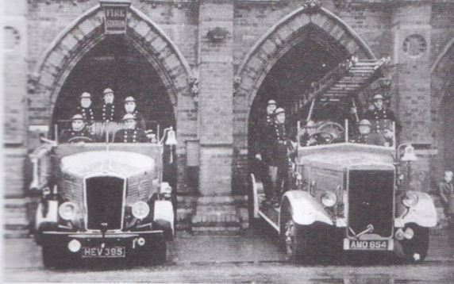
Picture from Ken Goatley's “Wokingham: the town of my life”.
In June 1860 the Wokingham police force, together with one of their two manual fire engines, moved into their new headquarters in the new Town Hall. The Wokingham Volunteer Fire Brigade took over the responsibility of firefighting from the police force in 1876.

15. 3 Market Place: Fonehouse, was once Mr. Jefferies, the Coal Merchant.
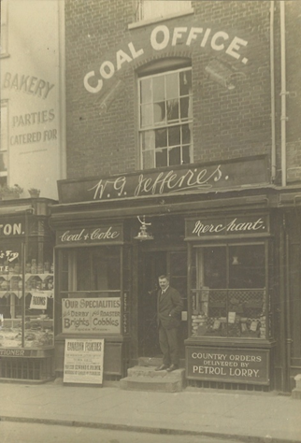
A photograph of Mr. Jefferies, the coal merchant, outside his shop in the Market Place.

16. 3 Market Place: Cancer Research UK Charity Shop, was once W. Chambers, Baker, Confectioner, Wines & Ales.
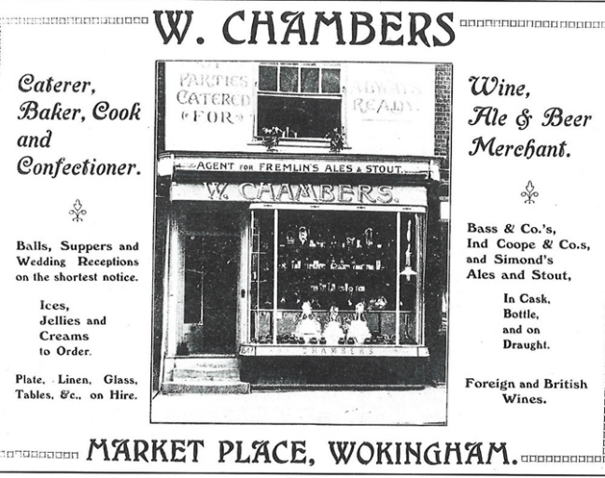
William Chambers was a caterer, baker and confectioner who also sold beer in casks and bottles at his shop at No. 4 Market Place.

17. 5 Market Place, Blandy & Blandy Solicitors, was once Buckmaster and then Bullocks Ironmonger.
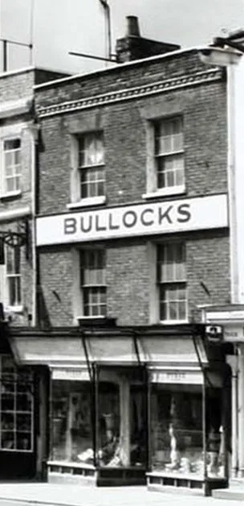
Bullocks was an old- fashioned ironmongers in the 1970s, and in the premises before Bullocks it was Joseph Buckmaster who moved from Hertfordshire to set up his ironmongers’ shop.

18. 7 Market Place: Sultan Indian Restaurant, was once Ye Tuck Shoppe.
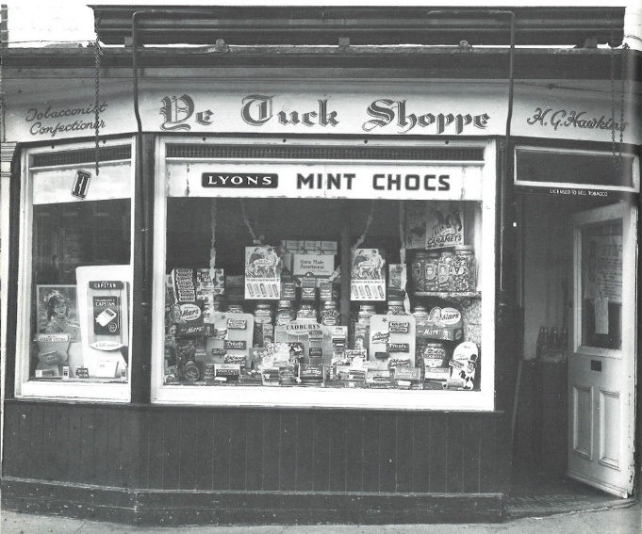

Ye Tuck Shoppe was a popular sweet shop run by Harry “Frump” Hawkins.

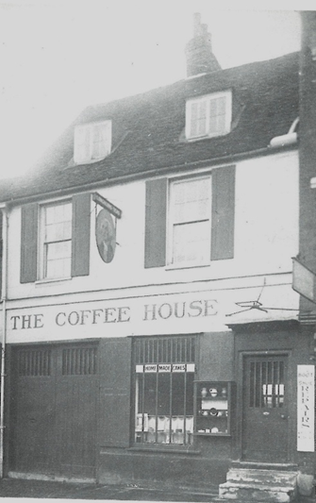
19. 11 Market Place: Vodaphone, was once The Coffee House.
The Coffee House was at No. 11 Market Place in the 1930s. The 18th century building was used as a garage up to 1910 and was a wire rope shop in the early 1920s.

20. 13 Market Place: Helen & Douglas House Charity Shop, was once Albert Goswell, Taylor.
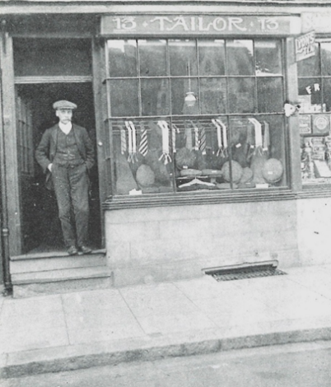
For over 40 years, Mr. Albert Goswell had a tailor’s shop at No. 13 Market Place. He specialised in hunt and livery clothing. He also served for nearly 40 years in the Wokingham Fire Brigade, rising to the rank of lieutenant.

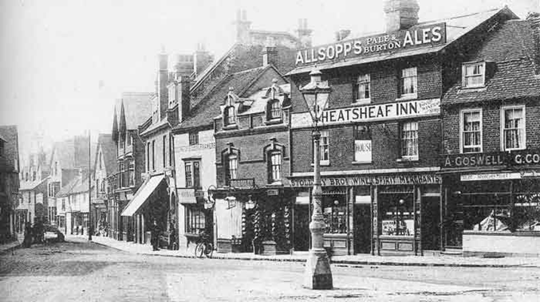
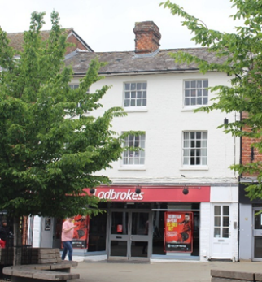
21. 14 & 15 Market Place: Ladbrokes, was once The Wheatsheaf Inn

The picture on the right is a view from Market Place looking down Denmark Street. The Wheatsheaf Inn is an early 19th century building.
22. 18 Market Place: Specsavers, was once Clark and Sons, Grocery.
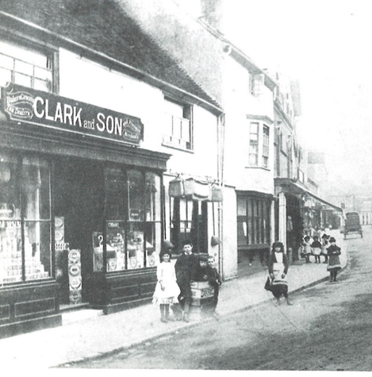
Clark and Son was one of a number of grocers that were in this premises in Denmark Street. The associated photograph was taken in 1900. The building was also where the “Wokingham Times” was first produced and has since been rebuilt.

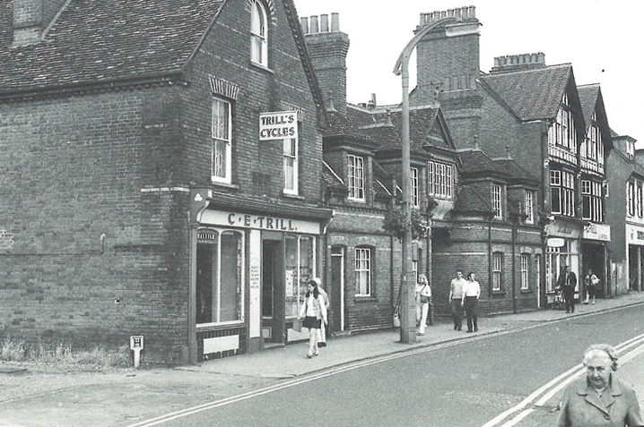
23. 13 Denmark Street: Mooboo Bubble Tea, was once Trill, Cycle Shop.
Many people in Wokingham bought their bicycles from Jack and Pip Trill’s cycle shop until it closed in the 1970s.
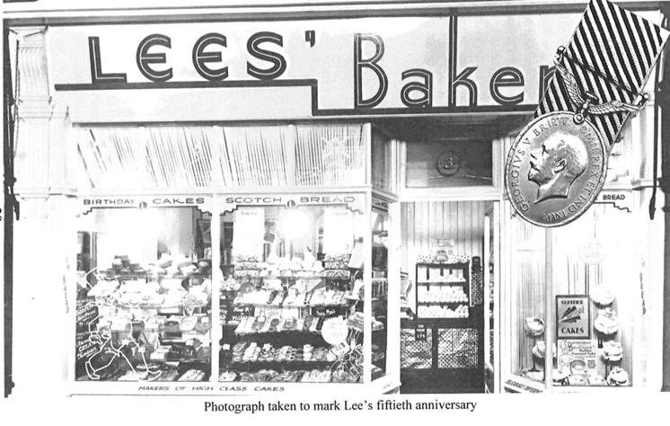
24. 3 Denmark Street: Giggling Squid, was once Lee’s Bakery.
Charles Lee, owner of a chain of baker’s shops in the south of England, opened early in 1931. When bread rationing was introduced Charles Lee’s son Harold was appointed Area Bread Officer.
25. 51 Denmark Street: Just Around the Corner (JAC) was an antique shop.
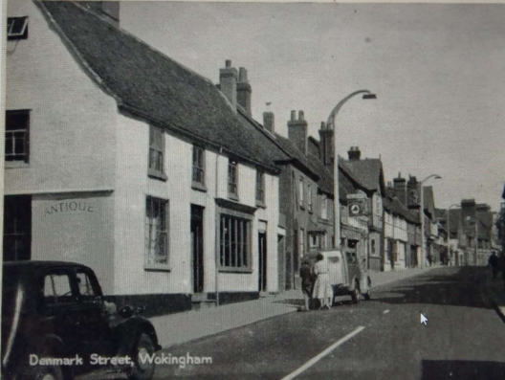
Although it says Antique on the side of the shop, Ken Goatley refers to it as a “bric-a-Brac “shop in his book “Wokingham: The time of my life”. The building, believed to be one of the oldest in Wokingham, dates to the 14th century. It is thought to have been two cottages originally, as evidenced by changes in the brickwork. In the 1940s it was run by Mr. M. Bookman, a grocer who bought a house in nearby Gypsy Lane and called it “Bramley”.
26. 2 Denmark Street: Characters café, was once Elizabeth Lenn, Fashion Shop, and earlier Mr Brant, photographer.
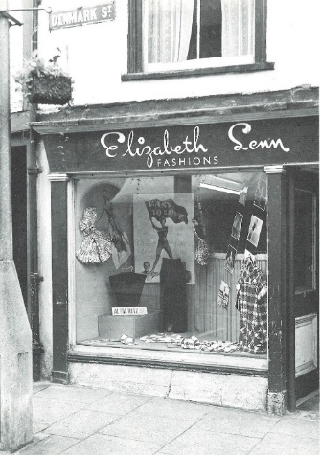
Elizabeth and Len Freeman ran a fashion shop from No. 2 Denmark Street. It was formerly the studio of Mr. Brant, a well-known photographer in the town.

27. 9 Market Place: Nandos, was once Walker Stores and, before that, a succession of other grocers.
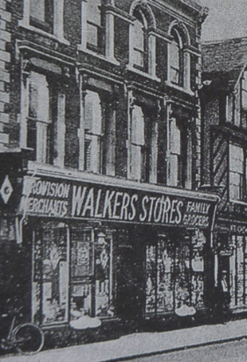
From the 1800s to 1970 it was a succession of grocers – the Butler Brothers, Skilton’s Stores, Grimbley & Hughes, Walker’s Stores.
Of the early inhabitants Henry and Edwin Butler were renowned as Britain’s oldest motor cyclists. They put their helmets down at the ages of 83 and 79. Edwin also rode a boneshaker made from gas pipes – no need for a bell for him as he could be heard a quarter of a mile away.
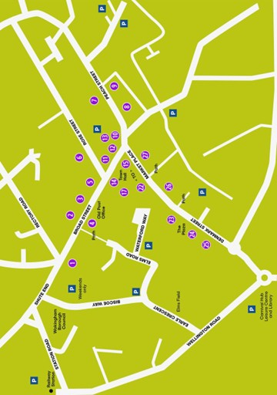
Locations of Traders: Positions are indicative
Ref | Trader Then | Where | What Now
1 | W. H. Howard, Ironmonger | Shute End 2 | Bosphorus barber shop.
2 | Montague House | Broad Street 31 | Calks Restaurant
3 | Pither & Son, Butcher | Broad Street 15 | Flower Corner Florist
3 | Paris House, Tailor | Broad Street 15 | Flower Corner Florist
4 | The Electric Theatre | Broad Street 10 | Nationwide
5 | James Watts, Estate Agent | Broad Street 7 | Winkworth Estate Agents
6 | F. Knight, Plumber | Rose Street 16-18 | WADE charity shop
7 | Somerscales Fish Bar | Peach Street 26 | Haka Chinese Take Away
8 | Evans, Leather Shop | Peach Street 19 | Hollland & Barrett
9 | J.Jordson, Greengrocer | Easthampstead Road 7 | Empty at the moment
10 | Bush Hotel | Market Place 37 | Grape Tree
11 | Boots | Market Place 38 | Peach Dental Care
12 | John Eighten, Fishmonger | Market Place 40 | Boots
12 | Heelas Department Store | Market Place 40 | Boots
13 | T. Maris, Saddler and Harness Maker | Market Place 41 | Boots Optician
14 | Fire Brigade | Town Hall Unit 1 | Piccolo Arco
15 | Mr. Jefferies the Coal Merchant | Market Place 3 | Fonehouse
16 | W. Chambers, Baker, Confectioner, Wine & Ales | Market Place 4 | Cancer Charity Shop
17 | Bullocks, Ironmonger | Market Place 5
18 | Ye Tuck Shoppe, Tobacconist and Confections | Market Place 7 | Sultan Indian Restaurant
19 | The Coffee House | Market Place 11 | Vodaphone
20 | Albert Goswell, Taylor | Market Place 13 | Helen & Douglas House charity shop
21 | Wheatsheaf Inn | Market Place 14-15 | Ladbrokes
22 | Clark and Sons, Grocery | Market Place 18 | Specsavers
23 | Trill, Cycle Shop | Denmark Street 13 | Mooboo Bubble Tea
24 | Lee's Bakery | Denmark Street 3 | Giggling Squid
25 | Antique/bric-a-brac Shop | Denmark Street 51 | Just Around the Corner
26 | Elizabeth Lenn, Fashion Shop | Denmark Street 2 | Characters
27 | Walker Stores | Market Place 29 | Nandos

The Wokingham Society
This document has been produced and paid for by the Wokingham Society, which is a Civic Society established in the 1960s to combat the threat to the town's buildings and facilities from widespread and often thoughtless redevelopment. Although it has not always been possible to prevent the loss of individual landmarks, the Society's voice has been significant in helping to preserve many local historical features and to ensure that development has been sensitive to the town's heritage.
The Society's aims are clearly set out in the constitution which is available on the website www.wokinghamsociety.org.uk but its main purposes may be summarised as:
• Encouraging the conservation of the character and traditions of Wokingham as a historic market town
• Promoting study of the history of Wokingham and interest in our heritage, for which this document supports
• Welcoming new development and business which enhance and invigorate the town while constructively opposing measures that do not
• Proposing improvements to the town's environment and amenities
To contact The Wokingham Society please email the Chairman or the Secretary, whose email addresses are available from the website.

